Aufgabe 1

 |  |  |  | 10 | 5 | 8 | 3 | 1 | 7 | 4 | 9

 | 10 | 5 | 8 | 3 |  |  |  |  |  | 1 | 7 | 4 | 9

10 | 5 |  |  | 8 | 3 |  |  |  | 1 | 7 |  |  | 4 | 9

10 |  | 5 |  | 8 |  | 3 |  | 1 |  | 7 |  | 4 |  | 9

5 | 10 |  |  | 3 | 8 |  |  |  | 1 | 7 |  |  | 4 | 9

 | 3 | 5 | 8 | 10 |  |  |  |  |  | 1 | 4 | 7 | 9

 |  |  |  | 1 | 3 | 4 | 5 | 7 | 8 | 9 | 10

Aufgabe 2

temp  array
  left | middle | right
  0 | 3 | 7
  0 | 1 | 2 | 3
  2 | 7 | 11 | 19
  0 | 1 | 2 | 3 | 4 | 5 | 6 | 7
  2 | 5 | 7 | 11 | 18 | 19 | 21 | 28
  i | j | k
  0 | 4 | 0
  1 | 4 | 1
  1 | 5 | 2
  2 | 5 | 3
  3 | 5 | 4
  3 | 6 | 5
  4 | 6 | 6
  4 | 7 | 7

Aufgabe 3
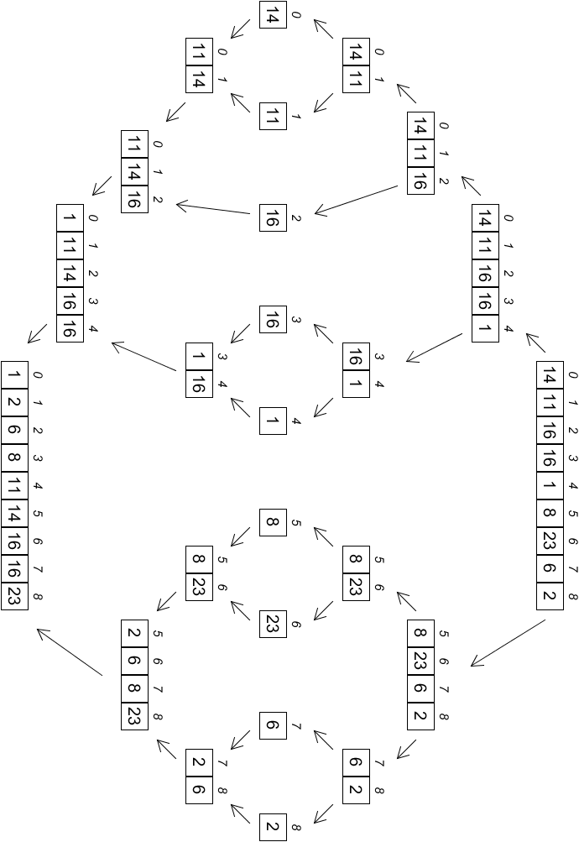

Autor: Christian Pothmann – cpothmann.de, freigegeben unter CC BY-NC-SA 4.0, Juni 2021

